**Executive Summary**

A widespread vaccination program will play a key role in New Zealand’s potential exit strategy for COVID-19. A vaccine for COVID-19 will take time to develop, and may not provide complete immunity and lose effectiveness after only a short period. This report mathematically models the spread of COVID-19 to show such an ineffective vaccine will need to be administrated approximately every 1 year and 4 months. By doing this the number of deaths caused by COVID-19 would be decreased from 68571 to 1718. Similarly, the number of days where the hospital capacity is exceeded would be minimised to 0, further decreasing the cost to public health. However, by administrating vaccines every 2 years and 4 months, sufficiently fewer casualties will occur in the long term in addition to balancing economic and social factors.

**Introduction**

New Zealand has been relatively successful in controlling the COVID-19 epidemic, with a total of 1,499 cases as of 6/10/2020 across a country of over 5 million (WHO, 2020). However, to prevent the reoccurrence of COVID-19 in the community, New Zealand needs an exit strategy for COVID-19. One potential component of this strategy is a widespread vaccine. A vaccination program would reduce the number of community transmissions and prevent a “second wave” from occurring.

However, a perfect vaccine is unlikely. COVID-19 is caused by a strain of the coronavirus, which can also be responsible for the common cold. According to the CDC (2020), vaccines developed for the common cold often only provide immunity for one season (from six months to one year), and only reduce the chance of showing symptoms by around 40-60%. Therefore, it is not unreasonable to assume that the potential COVID-19 vaccine will have the same flaws.

Given this information, it is important that the New Zealand government vaccinates a sufficient proportion of the population to prevent the large scale spread of COVID-19, and revaccinates the population in order to ensure that the immunity does not wane over time. These factors need to be investigated to balance public health with the economic cost of producing and issuing a widespread vaccination program.

**Non-technical Model Description/Methods**

Although a vaccine has not been found for COVID-19, research has been conducted about the disease that will act as the basis for modelling. The average incubation period before individuals show signs of symptoms (and hence become infectious) according to the WHO (2020) is around 4 days, and the average infectious period is around 10 days, after which individuals either stop showing symptoms or stop transmitting COVID-19. The RO value, the initial number of people an infected individual will infect is around 2.5.

To model the spread of COVID-19 and a potential vaccine, a SEIR model is used. This model divides the population into four classes with differing functionality: susceptible, exposed, infectious and removed. The overview of the model is shown in **Figure 1.**

Individuals susceptible to COVID-19 can be vaccinated, moving them from the susceptible to removed class, where they cannot be infected. Varying this process will be the focus of the report.

Susceptible individuals have a chance to become infected when they are near individuals in the infectious class – therefore, the more infectious individuals, the more susceptible individuals become infected with COVID-19. Once infected, individuals move to the exposed class, where they do not show symptoms and so do not infect susceptible individuals. After an average of 4 days, the individuals move to the infectious class. A further 10 days and infectious individuals can no longer infect susceptible individuals, and so are moved to the removed class, containing individuals who are either dead, vaccinated or otherwise immune. However, after an average of one year, individuals lose immunity and are moved back to the susceptible class.

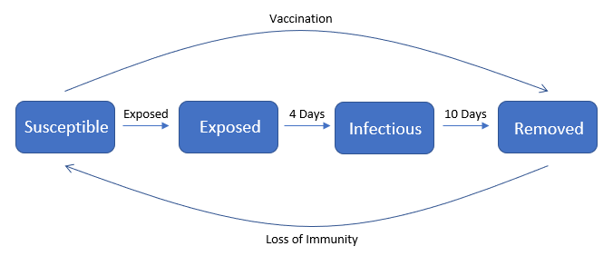

***Figure 1****: Overview of the SEIR model and its 4 classes*

This model does make a few key assumptions. Individuals who die from COVID-19 are not fully considered, as they are transferred to the removed class after being infected. The dead can then be transferred back to the susceptible class by loss of immunity and reinfected, which is not possible. However, given the relatively low fatality rate of COVID-19 of around 1%, this assumption will not greatly impact the model.

It is also assumed that the R value is relatively low throughout the entire epidemic. Without any intervention, the R value for COVID-19 is around 2.5. However, New Zealand has been very proactive with contact tracing in addition to hygiene and social distancing, which drastically reduces the R value. Therefore, it is reasonable to assume that the R value for COVID-19 in New Zealand is kept relatively low at a little over 1, even without lockdown intervention.

The model assumes that everyone can be vaccinated. This is not the case as some individuals will be too old or have insufficient health to safely receive the vaccine. However, as this is a minority of the population, it will likely not affect the model on a large scale.

The model does not consider a changing fatality rate. If the number of hospitalised cases exceeds the hospital capacity, then both COVID-19 patients and other critical patients cannot receive adequate health care. As a result, fatalities from not just COVID-19 but also other illnesses will increase. Therefore, the total deaths predicted by the model is likely lower than what would be expected if the number of active cases exceeds the hospital capacity.

A timeline for the model can be found in **Figure 2**. The outbreak begins on day 0, with 10 cases. Because the outbreak is small, little is done to contain COVID-19, resulting in an R value larger than 1, and so there is an increase in cases. To model the situation in New Zealand, a national lockdown is implemented on day 30. This decreases the R value to below 1, resulting in a decrease in cases. However, on day 200, the final lockdowns are eased, resulting in the R value increasing to above 1 again. A vaccination takes time to develop, and even with many of the world’s best institutes working on development of a vaccine for COVID-19, it is likely that even the best scenario would result in a vaccine by the end of the year. As a result, the vaccination can be added to the model after approximately 280 days. After the vaccine developed, the number of cases depends on the vaccine distribution plan.

***Figure 2:*** *Outline of the timeline events for the model*

**Results**

To compare potential strategies, three different scenarios were constructed and compared. The first models no vaccine distribution; the second models a partial vaccination distribution; and the third models a high vaccination rate. The number of active cases for the three scenarios over time is shown in **Figure 3**. **Figure 3** can be distributed to a wider audience, as it clearly conveys at a glance the effect that a vaccine has on reducing cases. This clearly shows the effect of the vaccine, drastically decreasing the number of cases, even in the case of a partial vaccination.

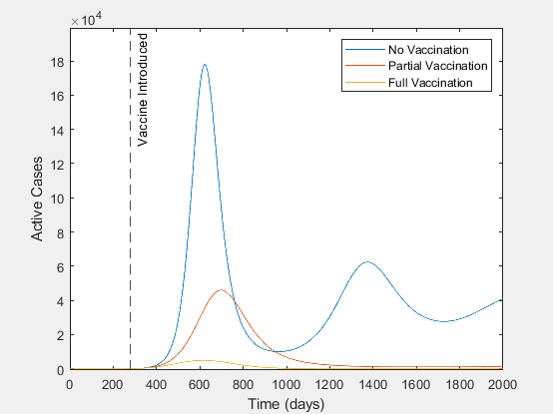

***Figure 3:*** *The number of active cases for the three possible vaccination strategies for 5 years after the vaccine is released.*

**Table 1** clearly shows the trend that as the number of vaccinations increases, the total deaths, infected and number of days spent over hospital capacity decreases. No vaccinations administrated results in 4 times the number of deaths compared to a partial vaccination strategy, and almost 40 times the number of deaths compared to a full vaccination strategy. It is also important to note that a full vaccination strategy has 0 days where the number of hospitalised cases is over the hospital capacity, which will likely result in the no vaccination and partial vaccination strategies experiencing a further increase in deaths in comparison.

|  |  |  |  |
| --- | --- | --- | --- |
| Strategy | Deaths | Total Infected | Days over Hospital Capacity |
| No Vaccination | 68571 | 6857051 | 1558 |
| Partial Vaccination | 17004 | 1700426 | 596 |
| Full Vaccination | 1718 | 171830 | 0 |

***Table 1:*** *Total deaths from COVID-19, total cases, and number of days spent over hospital capacity for each of the 3 vaccination strategies.*

**Figure 4** compares the predicted number of hospitalised cases compared to the hospital capacity. Clearly, both the scenarios where no vaccine is distributed and a vaccine is only partially distributed result in long periods of time where the number of hospitalised cases is above the hospital capacity. This would likely result in an increase in mortality rate for COVID-19 and other illnesses and widespread loss of life. It is important to note that a partial vaccination distribution would result in the number of hospitalised cases decreasing to below the hospital capacity after a period of around 1050 days.

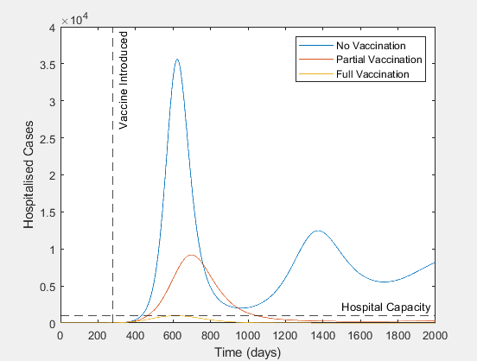

***Figure 4****: The number of hospitalised cases for the three possible vaccination strategies for 5 years after the vaccine is released, including the hospital capacity.*

**Discussion and Conclusion**

The best exit strategy is a high vaccination rate, as it vastly reduces the number of cases. Most importantly, this strategy results in 0 days spent over hospital capacity. This is key, as it both means that there are fewer fatalities directly from COVID-19, and means that other critical patients such as cancer patients can still receive medical care.

However, this strategy comes at a cost. To achieve these results, every individual in the population needs to be vaccinated approximately every 1 year and 4 months. This means that approximately 10,400 vaccinations need to be given out daily. A large-scale vaccination program like this would have a large economic cost to the country. However, it is likely that this economic cost would be less than performing national lockdowns every few months to limit cases.

A more economic strategy could include a partial vaccination rate, requiring vaccinations every 2 years and 4 months. This corresponds to approximately 5,900 vaccinations given out daily, almost half of that required for a high vaccination rate and hence having less economic cost. In the long term, this would ensure that the number of active cases is below the hospital capacity, limiting the number of deaths. However, this would still result in large spikes of active cases in the short term, resulting in almost 10 times as many deaths compared to the high vaccination rate for only half the cost. Therefore, this strategy is not preferrable.

Overall, a high vaccination rate of approximately 10,400 individuals every year is the best method for containing COVID-19. Despite the potentially high cost of vaccinating the population, this would drastically reduce the total number of cases of COVID-19.

**Technical Appendix**

The SEIR model resulted in the following system of differential equations.

$$Ṡ=-βSI-vf(S)+ωR$$

$$Ė=βSI-σE$$

$$İ=σE-aI$$

$$Ṙ=aI+vf(S)-ωR$$

Where the parameters are defined as:

* β is the number of exposures per susceptible individual per day.
* v is the proportion vaccinations that are effective.
* f(S) defines the function of how many vaccinations are given to susceptible individuals per day.
* ω is the number of recovered individuals that lose immunity per day.
* σ is the number of progressions from exposed to infections individuals per day.
* a is the number of recoveries per day.

The specific parameters chosen to produce the above report are:

* β **=** RO/10
  + The average infectious period for COVID-19 is 10 days.
* RO =
  + 1.3 when 0 < t < 30 during the initial outbreak
  + 0.9 when 30 < t < 200 during the lockdown period
  + 1.3 when 200 < t once lockdown has been lifted
* v = 0.6
  + This assumption is due to the average proportion of effective vaccines for the common cold and flus at 40-60%.
* f(S)
  + No vaccination: f(S) = 0
  + Partial vaccination: f(S) = 1/850 * H(t-280)
  + Full vaccination: f(S) = 1/480 * H(t-280)
  + As a more ambitious vaccination program requires vaccinations more frequently. The vaccination is only introduced after 280 days.
* ω = 1/365
  + The assumption has been made that the vaccine is only effective for an average of 365 days, which is typical for common colds and flus.
* σ = 1/4
  + The average time before an exposed individual becomes infectious is 4 days.
* a = 1/10
  + The average time before an infected individual recovers is 10 days.

It would have been possible to start the model from t=280 with around 100 infected individuals, ignoring the first 280 days. However, this would have led to fewer individuals in the removed category. As a vaccination moves individuals to the removed category, this would change the affect of the vaccination. Hence, the model was started from t=0 with varying R values over time to simulate lockdowns to increase accuracy.

An SEIR model was used over an SIR model due to accuracy. COVID-19 has a relatively long incubation period of 4 days, almost 1/3 of the full period which an individual is infected. As a result, combining the exposed and infectious classes would result in higher numbers of infection that what would likely occur, as individuals in the susceptible class are infected at rate βSI. If there is no exposed class, then both susceptible and infected will be higher, resulting in a higher number of infections than what would be expected in New Zealand’s scenario.

The system of differential equations was solved on MATLAB using ode23t with the initial condition of 10 infected and the rest of the population susceptible.

The graphs were produced by simply plotting y * 5 * 106 to approximate the New Zealand population against t.

The number of hospitalised cases and deaths were produced by multiplying the number of cases by the hospitalisation rate of 0.2 and infection fatality rate of 0.01 respectively.

Given that the vaccination rate is a fixed number subtracting from the susceptible population, an event handler was constructed to prevent the number of susceptible individuals falling below 0. If this did occur, the integration was stopped.

**References**

* WHO. (2020). *Transmission of SARS-CoV-2: implications for infection prevention precautions*. World Health Organization. <https://www.who.int/news-room/commentaries/detail/transmission-of-sars-cov-2-implications-for-infection-prevention-precautions>
* CDC. (2020). *Vaccine Effectiveness: How Well Do the Flu Vaccines Work?* Centers for Disease Control and Prevention. <https://www.cdc.gov/flu/vaccines-work/vaccineeffect.htm>
* WHO. (2020). *WHO Coronavirus Disease (COVID-19) Dashboard*. World Health Organization. <https://covid19.who.int/table>